Fall Detection Project USECASE



Ali Ossaily

Malak AL-Kazem

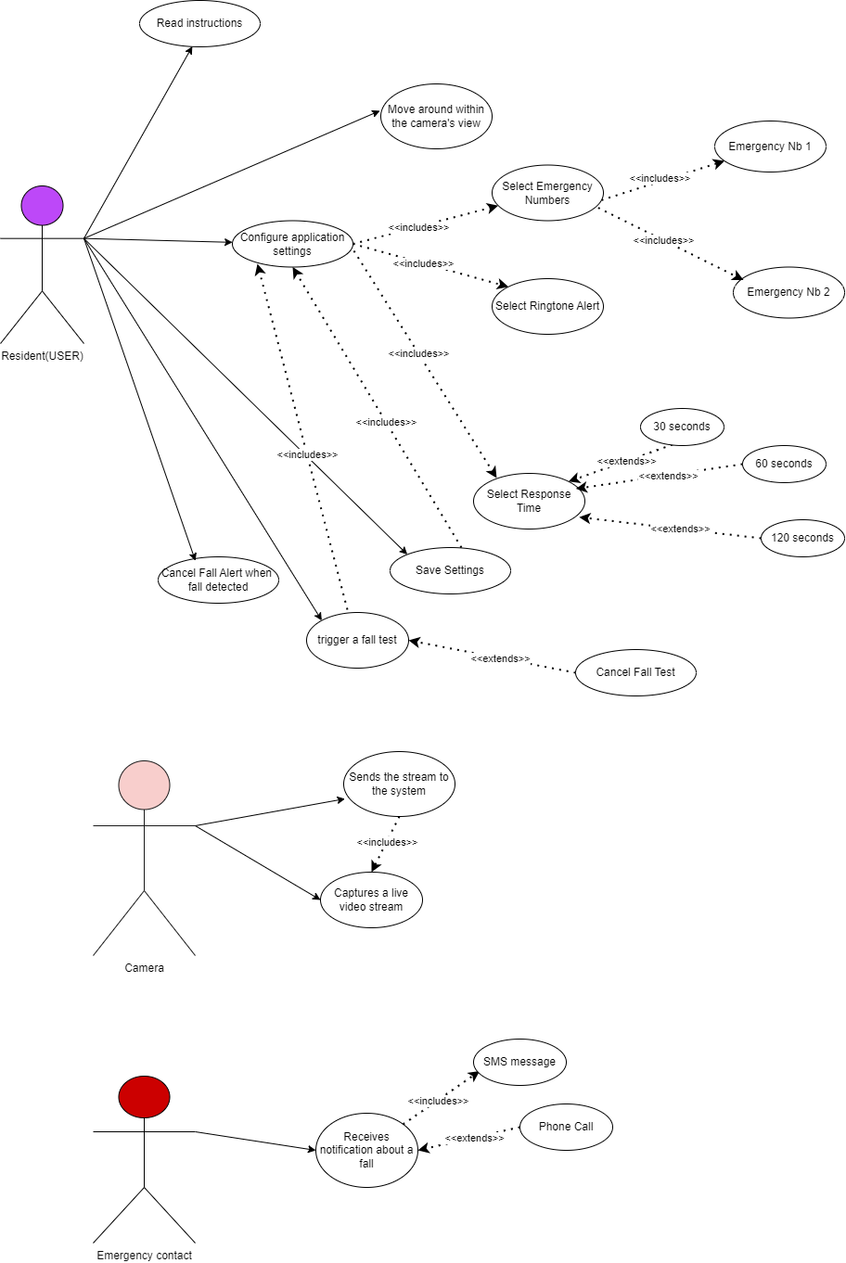

**Functional Requirements:**

* -Select Emergency Contact: This use case focuses on initiating emergency contact after a fall is detected. The system would automatically dial the local emergency number (based on the user's location) to connect with emergency services and dispatch help as quickly as possible.
* -Trigger a Fall Test: The purpose of this use case is to allow for testing the system's fall detection capabilities. The user would initiate a fall test through a designated method (e.g., button press, voice command) simulating a fall within the camera's view. The system's response would be to process the simulated fall and confirm if it can accurately detect the test scenario. This functionality helps ensure the system is working properly and provides peace of mind to the user.
* -Select a Response Time: This functionality allows the user to select the time before calling the emergency contact.
* -Select Ringtone: This functionality allows the user to change the alert ringtone.
* -Sends camera stream to the system.
* -Receive notification about the fall.
* -Resident: Cancel calling the emergency number.

**Nonfunctional Requirements:**

* -Fall Detection Accuracy: The system should accurately detect falls with a very low false positive rate (minimizing alerts for non-fall events).
* -Data Security: The system should securely store and transmit data, ensuring privacy for the user.
* -Response Time: The system should send emergency notifications with minimal delay after a fall is detected.
* -Scalability: The system should be scalable to accommodate additional users and cameras without compromising performance.
* Ease of Use: The system should be easy to install, configure, and operate for users with varying technical skills.
* -Privacy: The system should have clear privacy settings allowing users to control data collection and storage.

**Use-Case Narrative**

|  |  |  |
| --- | --- | --- |
| **Use-Case Name:** | Configure application settings | |
| **Use-Case ID:** | AT-001 | |
| **Priority:** | High | |
| **Primary Actor:** | Resident | |
| **Description:** | This use case describes the scenario where a resident configures the mobile application settings for fall detection. This includes emergency contact information, notification preferences, and response time. | |
| **Precondition:** | The resident has downloaded and installed the fall detection mobile application on their smartphone.  The resident has launched the application and accepted the permissions | |
| **Typical Course of Events:** | **Actor Action** | **System Response** |
| 1. The resident launches the application for the first time.   **If storage permissions are already granted**  The resident taps on the "Settings" menu option within the application.   1. The resident chooses one of the following:   **Allow:** The resident grants storage permission to the application.  **Deny**: The resident denies storage permission to the application.   1. The resident taps on the "Settings" menu option within the application. 2. The resident taps on the "Emergency Contacts" section. 3. The resident Add a new emergency contact by selecting him from contacts list opened. 4. The resident taps on the "Notification Preferences" section. 5. The resident selects their preferred notification settings. 6. The resident taps on the "Fall Response Time" section. 7. The resident chooses their desired fall response time from the available options (e.g., 10 seconds, 30 seconds, etc.). 8. The resident taps on the "Save" button to confirm all configuration changes. | 1. The application checks for necessary storage permissions (contacts and ringtones).   **If storage permissions are already granted**  The application displays the settings screen with various configuration options (Step #2 from original use case).  **If storage permissions are not granted:**   * The application displays a notification requesting permission to access storage for storing emergency contacts and ringtones. * The notification provides options for "Allow" and "Deny".  1. If Allowed: The application hides the permission notification and proceeds to display the settings screen   If Denied: The application deny the resident to enter settings page and configure settings   1. The application displays the settings screen with various configuration options. 2. The application displays a list of existing contacts saved on phone or a blank form to add new contacts. 3. The application saves the contacts accordingly. 4. The application displays options for customizing notifications upon fall detection, such as enabling/disabling ringtones, vibration alerts, and on-screen messages. 5. The application reflects the selected notification preferences. 6. The application displays options to set a delay before initiating a call to emergency contacts after a fall is detected. This allows the resident time to cancel the alert if it's a false positive. 7. The application saves the selected fall response time. 8. The application confirms the settings have been saved successfully. |
| **Postconditions:** | * If the resident grants storage permission, their emergency contact information, notification preferences, and fall response time are configured according to their choices within the application. * If the resident denies storage permission, the application might have limited functionality or return to the main screen. | |

2)

|  |  |  |
| --- | --- | --- |
| **Use-Case Name:** | Resident Triggers Fall Test | |
| **Use-Case ID:** | AT-012 | |
| **Priority:** | Medium | |
| **Primary Actor:** | Resident | |
| **Description:** | This use case describes the scenario where a resident intentionally triggers a fall test using the mobile application. This allows them to verify the fall detection functionality and emergency response process. | |
| **Precondition:** | * The resident has downloaded and installed the fall detection mobile application on their smartphone. * The resident has launched the application and configured their settings (including emergency contacts). | |
| **Typical Course of Events:** | **Actor Action** | **System Response** |
| 1. The resident taps on the dedicated "Fall Test" button within the application. 2. The resident chooses one of the following:   **Yes:** The resident confirms they want to proceed with the fall test  **No:** The resident decides not to perform the fall test at this time.   1. The resident, during the countdown timer, can tap on a "Cancel Test" button displayed within the application. 2. If the countdown timer reaches zero and the resident hasn't canceled the test | 1. The application displays a confirmation dialog box with a clear message like "Are you sure you want to initiate a fall test? 2. **If pressed NO**:   The application closes the confirmation dialog box, and the resident remains on the main screen. No test or notifications are initiated.  **If Yes:**  The application displays a countdown timer indicating the fall response time (as configured in the settings).  An SMS notification is sent to the emergency contacts informing them of a potential fall (clearly stating it's a test).  The selected alert activated on resident’s mobile   1. The application cancels the simulated fall alert.   The countdown timer stops.  No emergency call is initiated   1. The application automatically initiates a phone call to the primary emergency contact. |
| **Postconditions:** | If the resident confirms the fall test, one SMS notification is sent to emergency contacts, and potentially one emergency call is attempted (depending on if the resident cancels before the timer ends).  If the resident cancels the test, no notifications or calls are initiated. | |

3)

|  |  |  |
| --- | --- | --- |
| **Use-Case Name:** | Resident Reads Instructions | |
| **Use-Case ID:** | AT-114 | |
| **Priority:** | Low | |
| **Primary Actor:** | Resident | |
| **Description:** | This use case describes the scenario where a resident accesses and reviews the instructions or tutorials within the fall detection mobile application. This can include information about the application's functionalities, proper usage, and potential limitations. | |
| **Precondition:** | * The resident has downloaded and installed the fall detection mobile application on their smartphone. * The resident has launched the application. | |
| **Typical Course of Events:** | **Actor Action** | **System Response** |
| 1. The resident taps on a dedicated "Instructions" or "Help" button within the application. 2. The resident reads through the instructions, focusing on topics that interest them, such as:   How to configure emergency contact information and notification preferences.  Understanding the fall detection process and response time.  Troubleshooting common issues or limitations of the application.   1. The resident might choose to navigate through different sections of the instructions using provided menus or buttons. 2. The resident taps on a "Close" or "Back" button when they have finished reviewing the instructions. | The application displays a screen or opens a document containing detailed instructions on various aspects of the fall detection system. This information could be presented in different formats like text, images, or even short instructional videos.  The application closes the instructions screen and returns the resident to the previous screen they were on. |
| **Postconditions:** | The resident gains a better understanding of the fall detection application's functionalities and proper usage through the provided instructions. | |

4)

|  |  |  |
| --- | --- | --- |
| **Use-Case Name:** | Emergency Contact Receives Fall Alert | |
| **Use-Case ID:** | AT-005 | |
| **Priority:** | High | |
| **Primary Actor:** | Emergency Contact | |
| **Description:** | This use case describes the scenario where a designated emergency contact receives a notification and potentially a phone call due to a fall detection event triggered by the resident. | |
| **Precondition:** | * The resident has downloaded and installed the fall detection mobile application on their smartphone. * The resident has configured the application settings, including adding the emergency contact's phone number. * A fall event is detected by the Model | |
| **Typical Course of Events:** | . The fall detection model notifies the application on the resident's phone and registers a possible fall.    The emergency contact receives an SMS notification from the fall detection application.  Upon receiving the notification or phone call, the emergency contact takes necessary actions based on the situation, such as:  Calling the resident's phone number to check on their well-being.  Dispatching help to the resident's location (if the location information is provided).  Contacting other family members or emergency services depending on the urgency of the situation. | 1)The application initiates its emergency response protocol, which might include:  Sending an SMS notification to the emergency contacts listed in the app's settings.  Initiating an automated phone call to the primary emergency contact (depending on application configuration).  2)The notification clearly informs the contact about a potential fall incident involving the resident. It might include details like:  A message stating, "Fall Alert: [Resident's Name] may have fallen."  The resident's location information (if enabled and permitted by the resident's phone settings).  A link to a map app showing the resident's location (optional). |
| **Postconditions:** | The emergency contact is alerted about a potential fall incident involving the resident, allowing them to take appropriate action to ensure the resident's safety. | |